MODULE 1&2
Assingnment 1:

- What is the Web?
Ans: The Web (World Wide Web) is a collection of web pages that can be accessed using the Internet through a browser.
2. Difference between Web and Internet?
- Internet: A global network of computers.
- Web: A service that runs on the Internet to view websites.
3. What is a Website? Give two examples?
Ans: A website is a group of related web pages under one domain.
Examples: google.com, wikipedia.org
4. What is a Web Application? Give two examples?
Ans:A web application is an interactive website that performs tasks.
Examples: Gmail, Online Banking
5. What is Frontend development?
Ans:Frontend development deals with the user interface of a website (what users see).
6. What is Backend development?
Ans:Backend development handles server, database, and application logic.
7. Role of HTML in web development?
Ans:HTML is used to create the structure of web pages.
8. Role of CSS in web development?
Ans:CSS is used to style and design web pages.
9. Role of Bootstrap?
Ans: Bootstrap is a CSS framework used to create responsive and attractive websites quickly.
10. Name any two web browsers?
Ans: Google Chrome, Mozilla Firefox
Assignment 2: How Browsers Work

1. User enters a URL
User types a website address in the browser.
2. Browser sends request to server
Browser requests data from the web server.
3. Server sends response
Server sends HTML, CSS, and other files.
4. Browser renders the page
Browser displays the web page to the user.

Assignment 3: Real-Life Scenario

1.What will be included in the frontend?
Forms, buttons, pages, user interface.
2. What will be included in the backend?
Server logic, database, authentication, data processing.
3. Use of HTML, CSS, Bootstrap:
- HTML: Page structure
- CSS: Styling
- Bootstrap: Responsive design

Assignment 4: Practical Assignment
Create a simple HTML page with the following:
• Page title: My First Web Page
• Heading: Welcome to Web Development
• One paragraph explaining what HTML is
• One HTML comment saying: This is my first HTML page
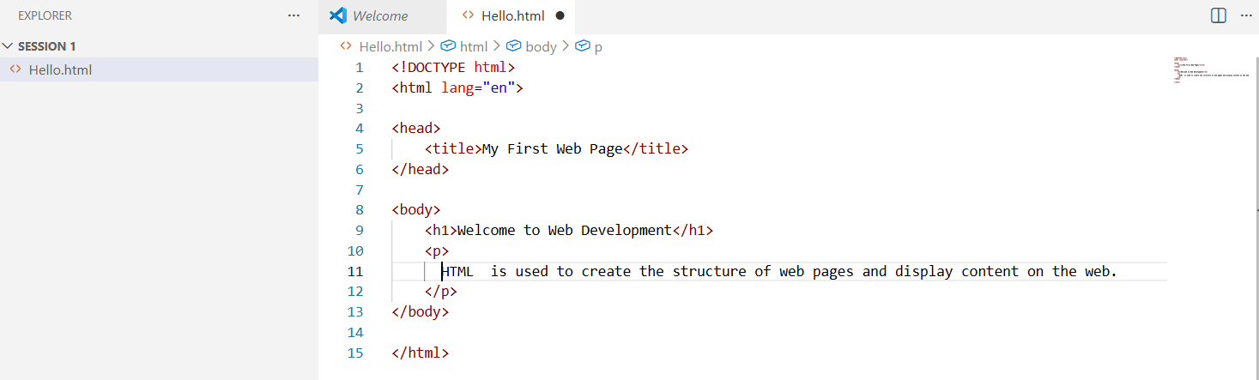

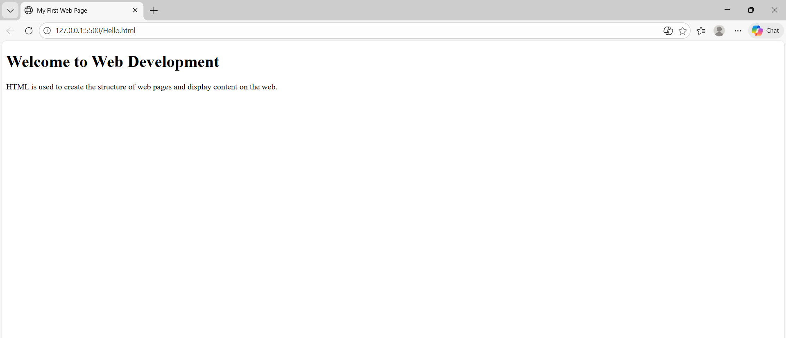

Assignment 5: Meta Tags
1. Use of <meta> tag
The <meta> tag provides information about the webpage like charset, description, and viewport.
2 How are meta tags useful for SEO?
Meta tags provide information about a webpage to search engines. They help improve search ranking, page description, and visibility in search results.
3. What is the difference between <title> and <meta> tags?
- <title> defines the page title shown on the browser tab and search results.
- <meta> provides additional information like description, keywords, and charset for browsers and search engines.

Assignment: Interview-Oriented Questions
1. Why do we use <!DOCTYPE html>?
It tells the browser that the document is HTML5 and ensures the page is rendered correctly

2. What is the difference between <head> and <body> tags?
- <head> contains metadata, title, links, and scripts.
- <body> contains the visible content of the webpage.

3. Is HTML case-sensitive? Explain.
No, HTML is not case-sensitive. Tags like <HTML> and <html> work the same.

4. How does a browser display an HTML page?
The browser reads HTML code, interprets tags, applies CSS, executes JavaScript, and then displays the webpage.

